User Manual

Interactive Planning

Abstract

Our project is based on the universal need to make work people 24/7 . The idea is to create an application more axed on the universal participative and the desire to the people to work.
The project is leading by Laurent Gout, Doctor emergengy to SAMU 31.

Doctor by schooling, Laurent Gout has also create an medical encyclopedia online for emergencys of CHU, established a geolocalization system and a medical files program for SMUR 31’s cars. finally, he developed an phonning interface program for SAMU 31.

Our project is based on the universal need to make work people 24/7 . The idea is to create an application more axed on the universal participative and the desire to the people to work.

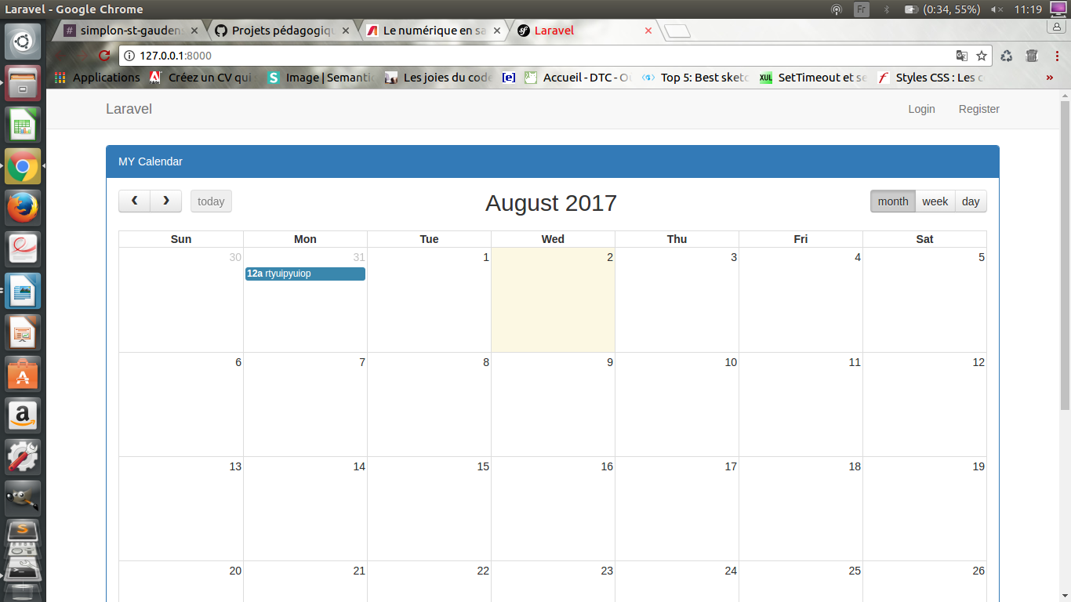

This is the home page, we found the calendar with the currents events. On top right we can connect if we have a account or create one .

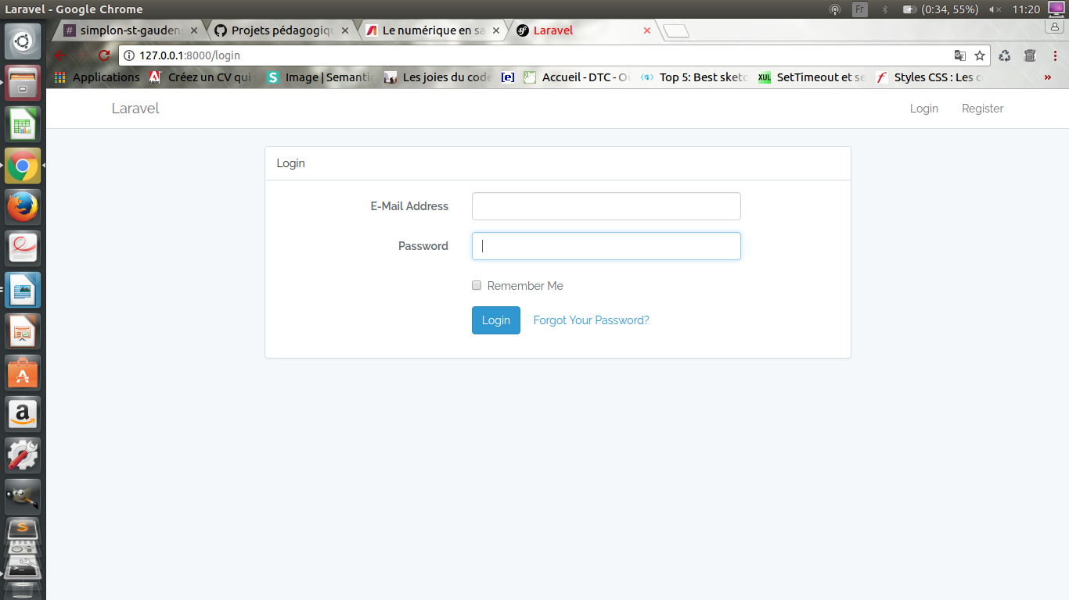

This is the connect page were we login if we have a account with email and password.

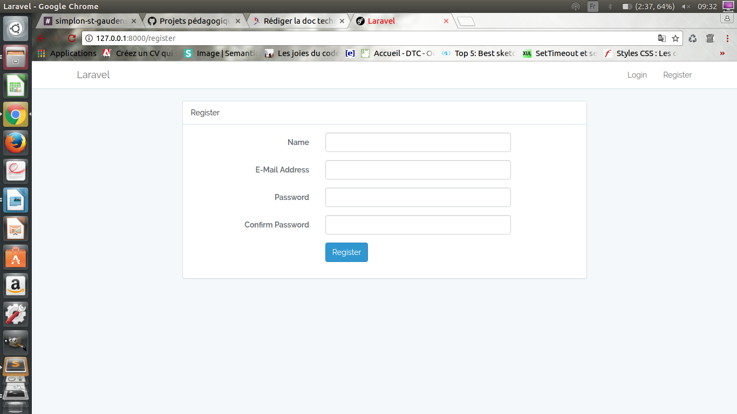
The register page allow to create a account we have to inform name, email and password.

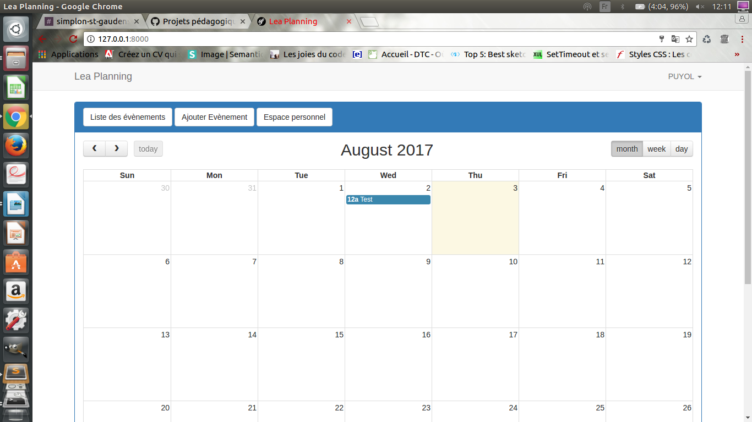
When we are connect we back to the calendar with the possibilty to add events or just check the currents events.

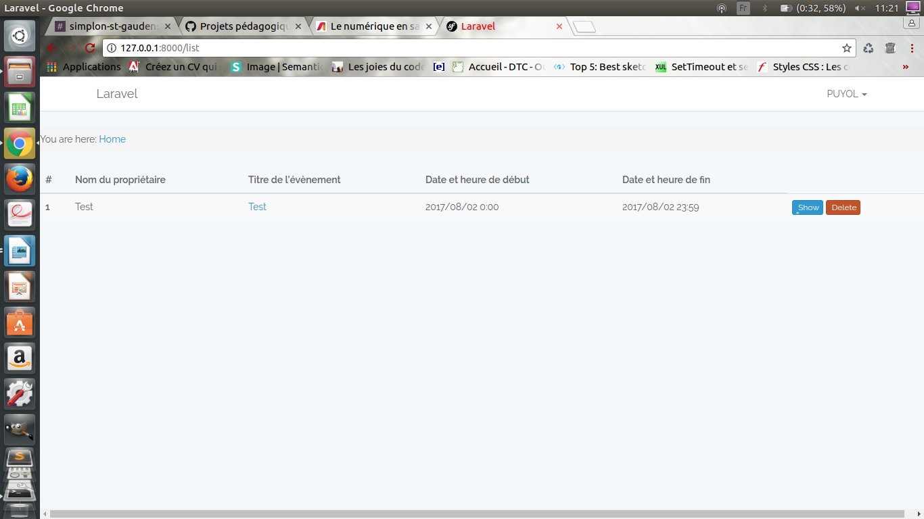
This the page with our currents events list. We can change or delete a event .

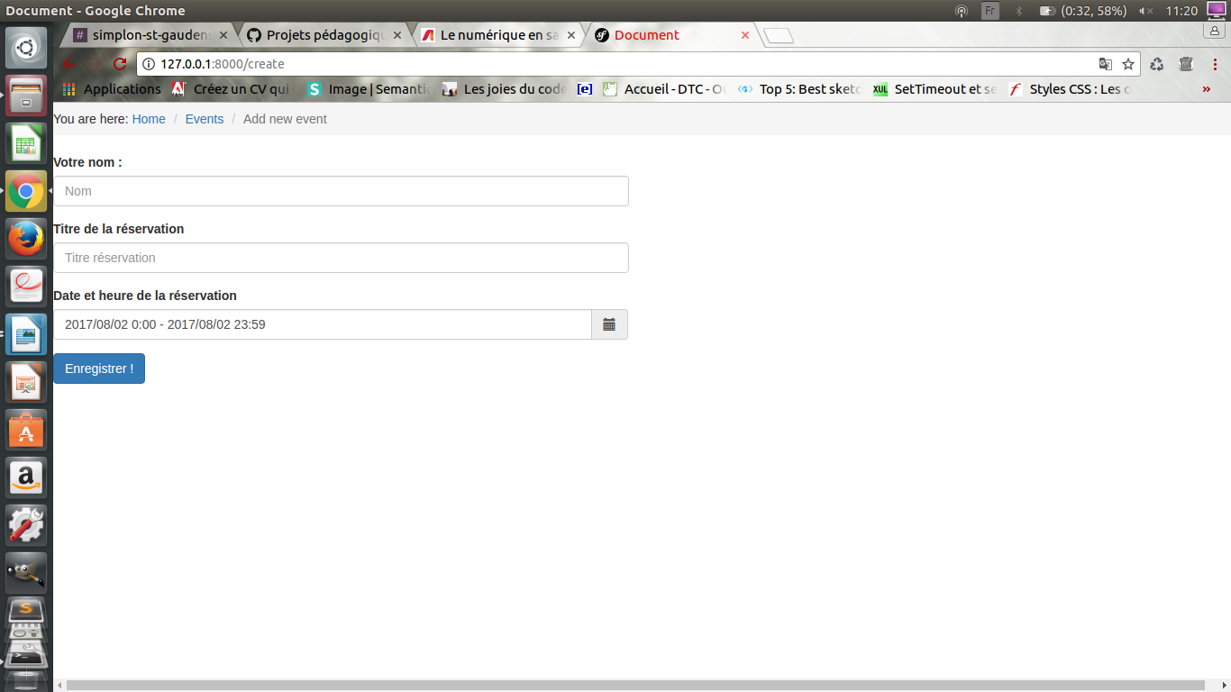

Here the register event list for add a event we inform the name the title and the date of the event (this is the same page for change a event).

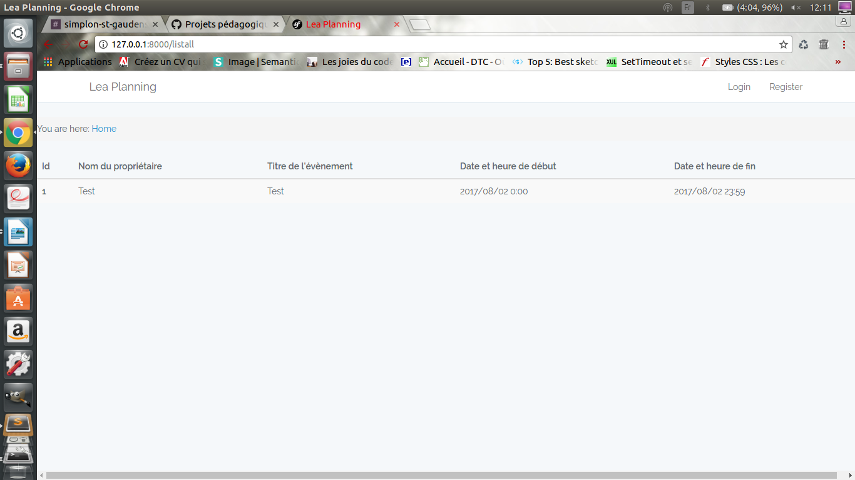

We can also check the page of all events list but we can’t change it .

